**LAB # 01**

**Artificial Intelligence**



**Name : Maryum Malik**

**Sap Id : 45369**

**Submitted to : mam Ayesha**

**Task 01:**

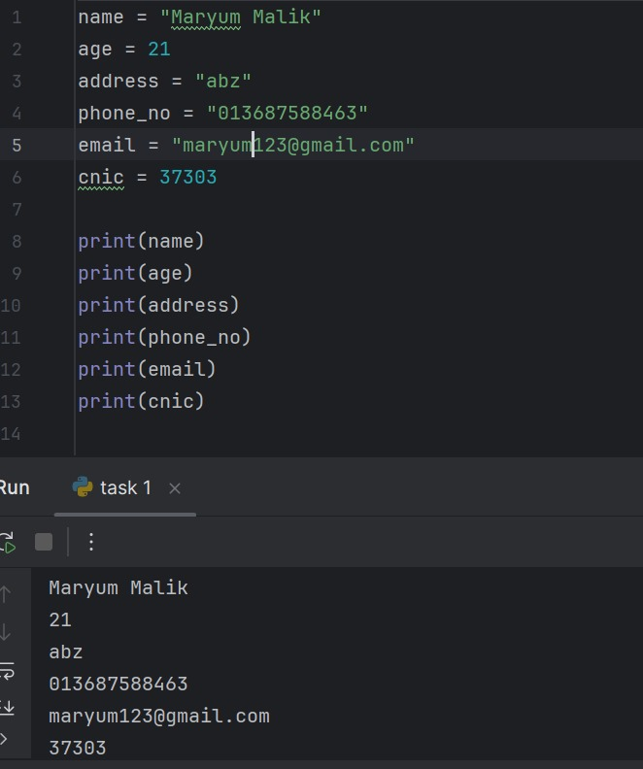

**Task 02:**

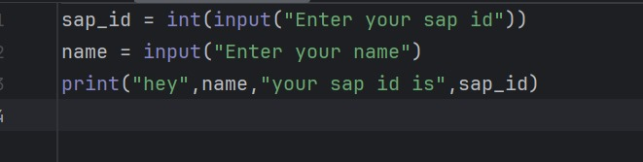

**Output:**

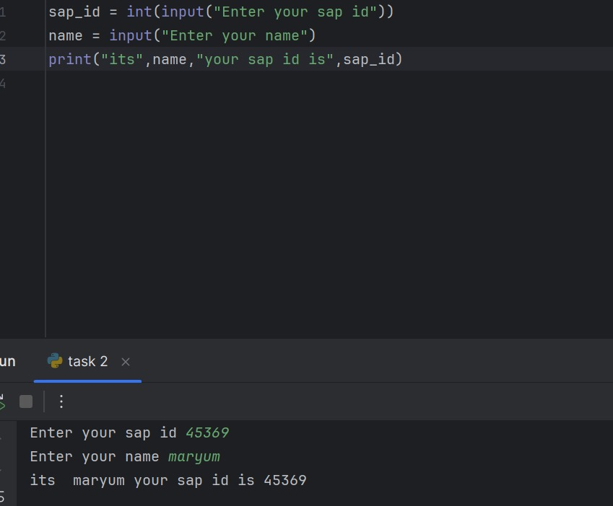

**Task 03:**

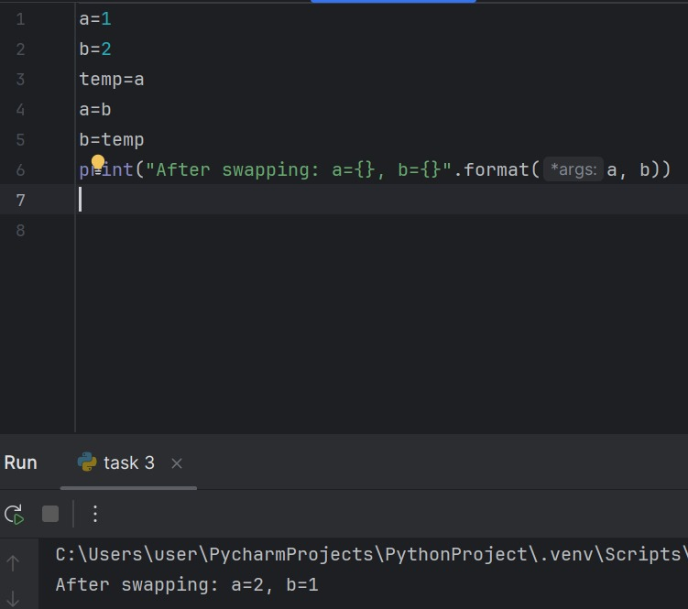

**Output:**

**Task 04:**

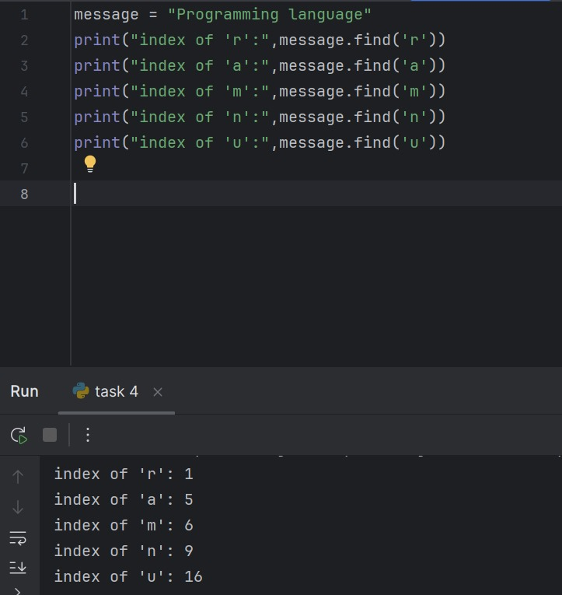

**Output:**



**Task 05:**

